Lectures 1 and 2 Review- Textbook Physics and Climate Concepts

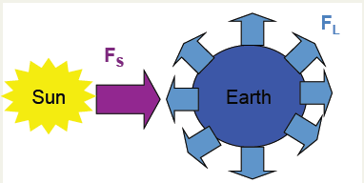
Energy Balance
Equivalent to 1st Law of Thermodynamics, ca. 1850
Energy In = Energy Out + Sources - Sinks
F_{s} = F_{L}
F_{s} = shortwave radiation, F_{L} = longwave radiation

Radiation
Stefan-Boltzmann Equation, ca. 1880
More Infrared Radiation = Higher Temperatures
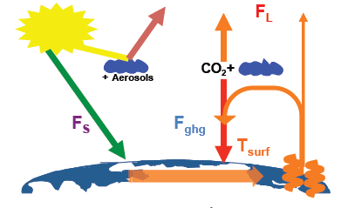
F_{L} = σT_{surf}⁴

Greenhouse Effect- 1858
Greenhouse effect is applicable for CO₂, clouds, water
F_{s} + F_{ghg} = σT_{surf}⁴
T_{surf} = 15ºC or 59ºF

White House Effect
For clouds (concept ca. 1950) and for aerosols
White “reflects” energy White House Effect
Black “absorbs” energy
More white on the surface of the Earth means more albedo.
Albedo = amount of reflection, high albedo leads to lower surface temperatures.
S_{o}(1-α_{p}) + F_{ghg} = σT_{surf}⁴
S_{o} = incoming solar radiation
α_{p} = outgoing reflected energy ~ 31%

Aerosol Cooling
Aerosols have direct and indirect cooling effects
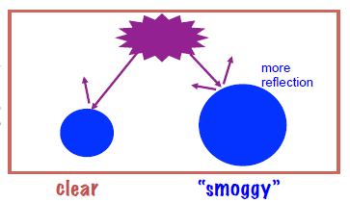
Aerosols cool directly by reflecting more light

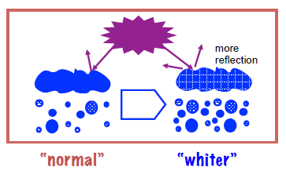
Aerosols indirectly cool by causing more clouds to form that reflect more light

Intergovernmental Panel on Climate Change (IPCC) 2007 report
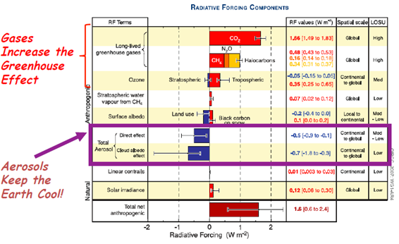
The IPCC summary states that:

“Warming of the climate system is unequivocal, as is now evident from observations of increases in global average air and ocean temperatures, widespread melting of snow and ice, and rising global mean sea level.”

“Most of the observed increase in globally averaged temperatures since the mid--‐20th century is very likely due to the observed increased in anthropogenic greenhouse gas concentrations.”

IPCC, 2007: Summary for policymakers. In Climate Change 2007: Impacts, Adaptation and Vulnerability. Contribution of Working Group II to the Fourth Assessment Report of the Intergovernmental Panel on Climate Change. M.L. Parry, O.F. Canziani, J.P. Palutikof, P.J. van der Linden, and C.E. Hanson, Eds. Cambridge University Press, pp. 7-22

